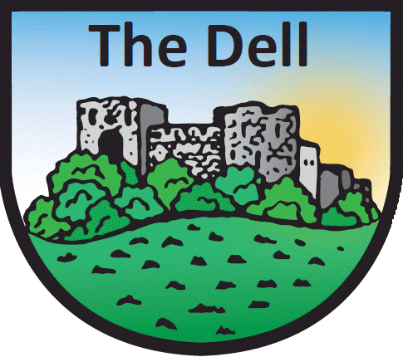
The Dell Primary School
WELSH LANGUAGE INFORMATION

Name of Child Class

The following questions ask about the Welsh language ability of the pupil and the use of Welsh in the home.

Please start at question 1 then follow directions.

- Can your child speak Welsh? Yes / No
If Yes, go to Q2. If No, (consider Q6) then go to THANK YOU section

Fluency in Welsh
Which of the following best describes your child’s fluency in Welsh (tick ONE box)

 | Speaks Welsh fluently | 1
 | Speaks Welsh but not fluently | 2

Does your child speak Welsh in the home? Yes / No
If Yes, go to Q4. If No, go to THANK YOU section

Speaking Welsh at home with parents or guardians
Which of the following best describes the use of the Welsh language by your child at home? (tick ONE box)
 | Speaks Welsh with one parent or guardian only | 1
 | Speaks Welsh with both parent(s) or guardian(s) | 2
 | Does not speak Welsh at home with parents or guardian(s) | 3

- Does your child speak Welsh in the home with his or her siblings? Yes / No

- I do not wish the information regarding Welsh language to be recorded (please tick box)

THANK YOU - Please save this form and send it to thedellprimary@monmouthshire.gov.uk

For school office use only
STATS1 category | 1 | 2 | 3 | 4 | 5 | 6  STATS1 (the aggregate school census) categories are:  - Speaks Welsh fluently at home with parents only  - Speaks Welsh fluently at home with siblings only  - Speaks Welsh fluently at home with both parents and siblings  - Does not speak Welsh at home but can speak Welsh fluently  - Speaks Welsh but not fluently  - Cannot speak Welsh
Q1 answer | Y | Y | Y | Y | Y | N
Q2 answer | 1 | 1 | 1 | 1 | 2
Q3 answer | Y | Y | Y | N | any
Q4 answer | 1 OR 2 | 3 | 1 OR 2 |  | any
Q5 answer | N | Y | Y |  | any
Pupil category (tick)
The source of the answers to questions 1, 2 and 3 is: | Parent
 | Pupil
 | School

Note that if the form is not returned by the pupil or parent then no data must be recorded for questions 4 and 5.

